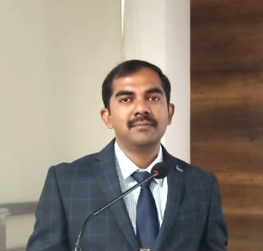
DR. MADHUSUDHAN T K
Designation: Associate Professor & HOD
Official Email ID: madhusudhantk_bba@rnsfgc.edu.in
LinkedIn ID: www.linkedin.com/in/dr-madhusudhan-t-k-5a976a39

Profile:
Dr. Madhusudhan T. K, Associate Professor and Head of the Department of BBA at RNS First Grade College, is a seasoned academician and trainer with over sixteen years of experience spanning academia and industry. A management graduate, he holds a B.Sc. from Kuvempu University, an MBA in Marketing from RNS Institute of Technology, and a Ph.D. from Visvesvaraya Technological University (VTU), Belagavi.
He has been instrumental in bridging the gap between academia and corporate practice by guiding students through career development initiatives and industry collaborations. As a dedicated soft skills trainer, he has been actively supporting rural students in training and placement, particularly at RNSFGC Murudeshwara, where he has provided assistance for the past four years.
Dr. Madhusudhan has contributed to academic literature by authoring a book on Environmental Studies, a compulsory course prescribed by UGC for undergraduate students across Karnataka, and by reviewing a book on Personality Development published by Skyward Publishers. He has also guided numerous students in projects and internships, nurturing their professional and research capabilities.
His academic leadership extends to serving on several institutional committees, where he has played a key role in governance and academic process improvement. In addition, he has presented and published research papers in national and international conferences, with many of his articles appearing in reputed journals.
Through his multifaceted contributions—as a teacher, researcher, author, and mentor—Dr. Madhusudhan T. K continues to enrich the academic environment of RNS First Grade College and inspire students to achieve excellence in both professional and personal spheres.

